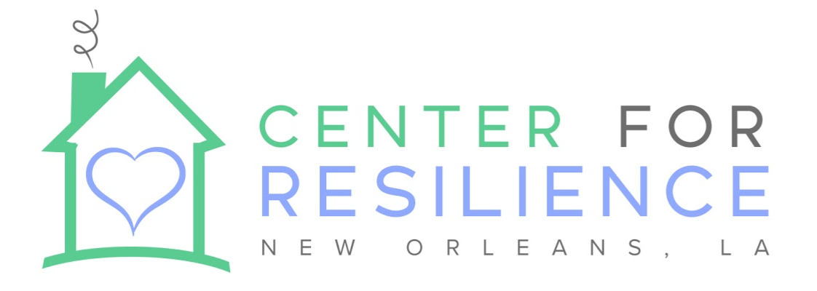

The Center for Resilience: About Us
The Center for Resilience is an independent non-profit, originally founded as the New Orleans Therapeutic Day Program, a collaboration among the Recovery School District, Orleans Parish School Board, and Tulane University Medical School’s Department of Child and Adolescent Psychiatry. We are a separate setting currently serving children in grades K-9. The center serves children with significant behavioral and/or mental health disabilities. Our mission is to provide clinically sound, academically effective, and culturally sustaining services to ensure the emotional well-being and academic readiness of children with behavioral health disabilities in the Greater New Orleans region.

More specifically, the Center provides a caring, therapeutic milieu with positive behavioral supports, trauma-informed approaches, evidence-based mental health practices, small-group classroom instruction, and therapeutic recreation activities. Our goal is to build students’ skills so they can transition back to their home school setting. We love children and believe in a strengths-based framework for working with even the most challenging of students. We believe healthy relationships are the cornerstone of any behavioral health growth, and expect our team members to model healthy relationships with one another and with the children with whom we work. Typically, students referred to The Center have moderate to significant emotional health needs. While there is no “typical” child at The Center, a student’s profile might include a history of hospitalizations, physically aggressive behaviors towards peers and/or adults, property damage, family and/or community trauma, challenges with impulsivity and executive functioning skills, internalizing/withdrawn behaviors, and/or self-injurious behaviors.

Mental Health Counselor Responsibilities and Qualifications:
The focus of this program is to successfully transition children back to their regular campus to achieve success. The Counselor is responsible for addressing four domains: individual student planning; system support; responsive services; and school counseling curriculum.

Individual Student Planning:
- Providing individual counseling to a caseload of up to 10 children per week.
- Leading group counseling sessions, as needed; may address a specific topic rather than age-based groups
- Maintaining weekly contact with clients’ primary caregivers and providing parent consultation or family counseling on site or in the home, as needed
- Providing crisis intervention
- Consulting and collaborating with client’s multidisciplinary team, which may include psychiatrist, psychologist, social worker, teachers, and milieu staff to identify and address child’s academic, behavioral, and mental health needs
- Attending IEP meetings, as needed
- Leading case staffing and treatment team meetings for assigned students
- Collaborating with School Partnerships Coordinator on intake and transition processes and planning
- Collaborating with home schools about students’ high school selections, as needed
- Attending regular clinical case staffings with multidisciplinary clinical team for planning and case consultation
- Establishing working relationships with representatives of other agencies who work with and provide services to individuals and families
- Connecting individual students to resources and specific areas of interest or need (e.g., arts and sports activities, mentorships)
- Completing all required documentation which includes but not limited to, progress monitoring, discharge planning, progress notes, treatment plans, quarterly reports, Individual Education Programs (IEP), and mandatory reporting requirements.
- Conducting school observations of referred students
- Conducting student interest inventories, as needed

System Support:
- Leading and/or consulting regarding social emotional learning curriculum, as needed
- Designing and leading professional development for staff members, as needed
- Collaborating with Therapeutic Support Coordinator and Family Liaison on community outreach

Responsive Services:
- Leading crisis counseling, as needed
- Facilitating restorative conversations among children and/or between children and adults

School Counseling Curriculum:
- Developing counseling initiatives and programming (such as mental health awareness month, etc.)

Knowledge, Skills and Abilities Required:
- A belief in positive interventions and supports and a strong commitment to providing a trauma-informed, therapeutic, positively-oriented experience to students with severe behavioral health challenges
- Proven track record in creating and maintaining a positive work environment
- Ability to proactively recognize and address obstacles and challenges
- Desire for continuous growth as a professional and ability to receive and incorporate feedback
- Ability to work effectively as a member of a team and ability to work in an innovative, start-up environment
- Flexibility, grit, and an asset-based mindset
- Possess a graduate level degree in counseling or social work and provisional or full licensure to practice in Louisiana. Those with provisional licensure must secure regular clinical supervision according to licensure requirements.
- Experience working with students with severe behavioral disabilities and trauma symptomatology strongly preferred
- On rare occasions, some evening or weekend hours may be required.

How to Apply
Interested candidates should send a resume and tailored cover letter outlining their experience and qualifications to Kate Geiss, Site Director/Principal, at kate.geiss@cfrla.org and CC Dr. Liz Marcell Williams, Chief Executive Officer, at liz.marcell.williams@cfrla.org

